**23CSE111**

**OBJECT ORIENTED PROGRAMMING**

**LAB REPORT**



**Department of Computer Science Engineering**

**Amrita School of Computing**

**Amrita Vishwa Vidyapeetham,**

**Amaravathi**

**Name: M.N.H.O.K .MANOJ**

**Roll No: 24214**

**Verified By :**

**INDEX**

|  |  |  |
| --- | --- | --- |
| **S.NO** | **week** | **Page No** |
| **1** | **Week-1** |  |
| **2** | **Week -2** |  |

|  |  |  |
| --- | --- | --- |
|  |  |  |

**Week-1**

|  |  |  |
| --- | --- | --- |
| **S.NO** | **Experiment** | **Page No** |
| **1** | **Installation of jdk21** | **3-4** |
| **2** | **Write a simple java program for printing Name, Class, Roll No, of a Student** | **5** |

**Week- 2**

|  |  |  |
| --- | --- | --- |
| **S.No** | **Title** | **Pg no** |
| **1** | **Write a java program to find simple interest where all inputs are taken from user** |  |
| **2** | **Write a java program to calculate factorial of a number , read the input from user** |  |
| **3** | **Write a java program to calculate the Fibonacci**  **Sequence of a input taken from user** |  |
| **4**  **A** | **Write a java program to convert temperature from Celsius to Fahrenheit** |  |
| **4**  **B** | **Write a java program to convert temperature from Fahrenheit to Celsius** |  |
| **5** | **Write a java program to calculate the area of rectangle** |  |
| **6** | **Write a java program to calculate the area of triangle by using heron’s formula** |  |

**Week -3**

|  |  |  |
| --- | --- | --- |
| **S.No** | **Title** | **Pg no** |
| **1** | **Create a java program with following instructions**   1. **Create a class with name car** 2. **Create four attributes named Car_color , Car_brand, fuel_type,mileage** 3. **Create three methods named start(),stop(),service()** 4. **Create three objects named Car1, Car2 and Car3** |  |
| **2** | **Create a class bankAccount with elements deposit() and Withdrawl** |  |

**Week -4**

|  |  |  |
| --- | --- | --- |
| **S.NO** | **Experiment** | **Page No** |
| **1** | Write a java program with class named book , the class should contain various attributes such as title , author , year of publication , it should also contain a constructor parameters which initializes title , author , year of publication  Create a method which displays details of the book  Display details of two books |  |
| **2** | Create a java program with class name myclass with static variable count of int type ; initialized to zero and a constant variable “pi’  Of type double initialized to 3.14 as attribute of that class , now define a constructor for “ my class “ that increment the count variable each time an object of my class is created count = 0 ,finally print the final values of “count” ans pi variable ,create 3 objects |  |

**WEEEK -1 (LAB )**

1. **Process of Installing JDK (Java Development Kit)**

**Installing JDK (Java Development Kit):**

* 1. **Download JDK:**
* **Go to the Oracle JDK download page in google and click on JDK-21 version which is Long term support (LTS) version.**
* **Click the download link as your operating system (Windows, macOS, or Linux).** 
  1. **Install JDK:**
* **Once downloaded, run the installer.**
* **Follow the given instructions and keep clicking "Next" until it is done.** 
  1. **Set Environment Variables (Windows):**
* **Open file explorer, then right click on This PC next select on properties then it will take you to the settings app then click on advanced system settings and then click on Environment Variables.**
* **Click on path and new under System Variables:**

**Variable value: The folder address where JDK is installed (like**

**C:\Program Files\Java\jdk-21\bin)**

* **Find Path under System Variables, click New, and add the path of the jdk-21(C:\Program Files\Java\jdk-21\bin)**

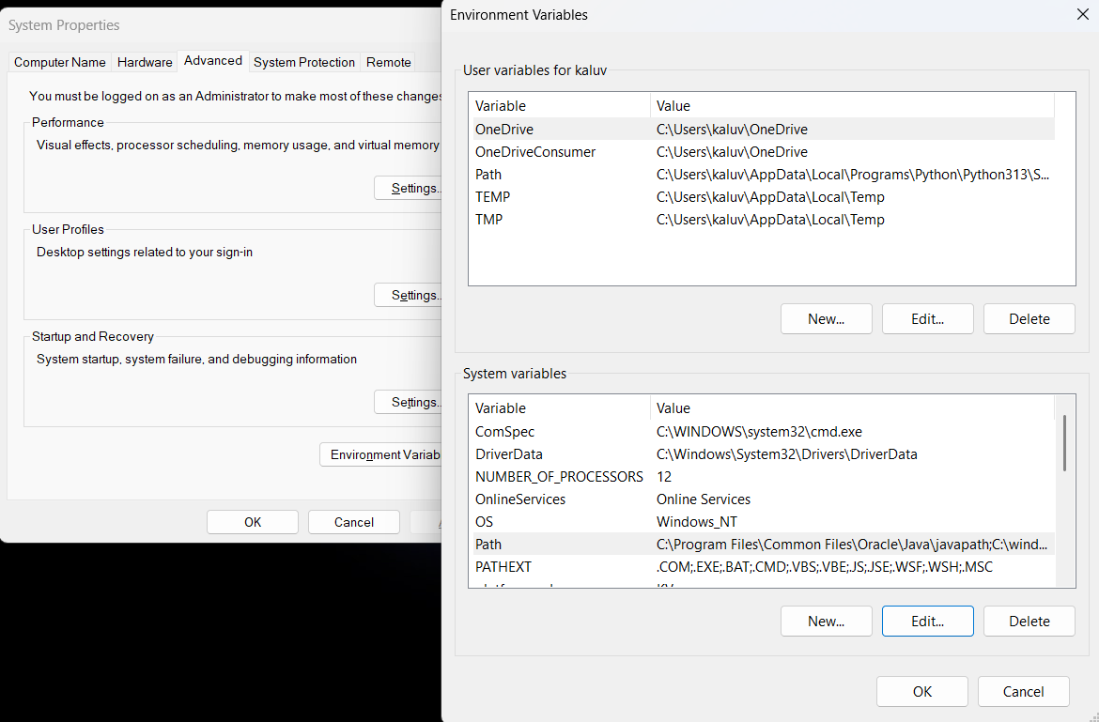

**Checking JDK Version: -**

* 1. **Open Command Prompt:**
* **Presswin+R, typecmd, and press Enter.** 
  1. **Check Version:**
* **Type java -version and press Enter.**
* **Type javac --version and press Enter.**

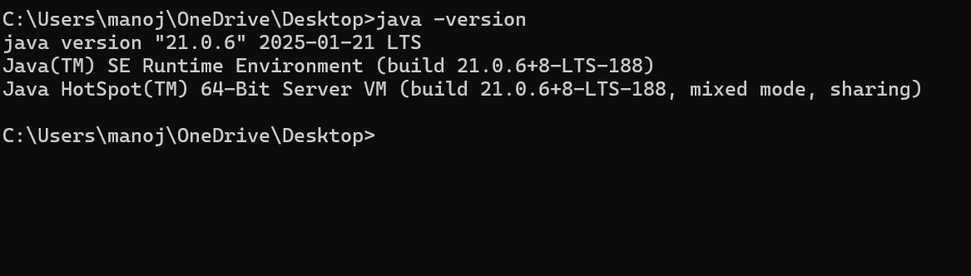

1. **Simple Java Program for printing Name, Class, Roll No, of a Student**

Write your code in Notepad and execute it in cmd prompt

**CODE: -**

Class manoj

**{**

**public static void main(String[] args)**

**{**

**System.out.println("Name: M.N.H.O.K. MANOJ ");**

**System.out.println("CLASS: CSE");**

**System.out.println("SECTION:C");**

**}**

**}**

**Output: -**

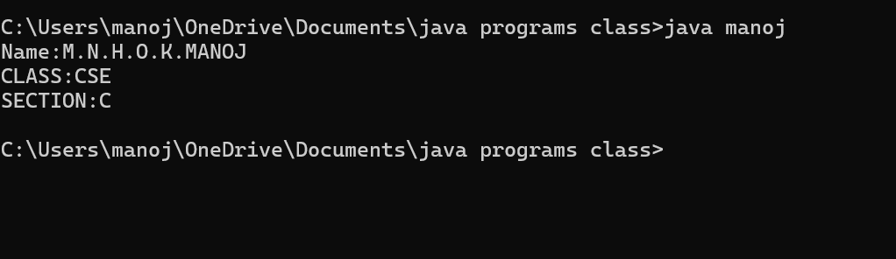

Errors:

|  |  |  |
| --- | --- | --- |
| 1 | Syntax error | Semicolon added |
| 2 | Runtime error | Copied correct path |
| 3 | Name error | rectified |

**WEEK -2 (LAB)**

**SIMPLE JAVA programs**

1. **AIM:**

**Write a java program to write area of rectangle.**

**Important points: AREA OF RECTANGLE IS AREA = LENGTH * BREATH**

**Code:**

class demo {

public static void main(string[] args) {

Scanner sc = new Scanner(System.in);

System.out.println(“enter a number:”);

int l = sc.nextInt();

System.out.println(“enter a number;”);

int b = sc.nextInt();

int a = l*b;

System.out.println(“area of rectangle is “+a);

}

**}**

**Output :**

**1.Positive case**

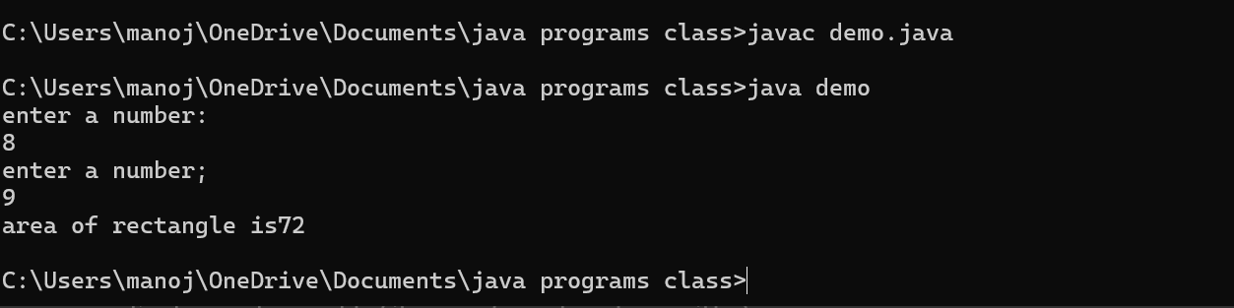

**2.Negative case :**

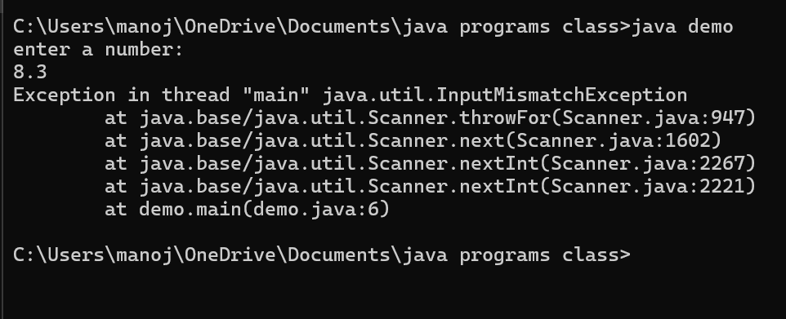

**Errors table :**

|  |  |  |
| --- | --- | --- |
| 1 | Syntax error | Semicolon added |
| 2. | Name error | rectified |

1. **AIM :**

**Write a java program to find simple intrest where all input from user**

**Code :**

import java.util.*;

class test{

public static void main(String[] args)

{

System.out.println(" taking input");

Scanner sc = new Scanner(System.in);

System.out.println("enter INTa number:");

float p = sc.nextFloat();

System.out.println("enter a number:");

float t = sc.nextFloat();

System.out.println("enter a num:");

float r = sc.nextFloat();

float s = (p*t*r)/100;

System.out.println("simple intrest is"+s);

}

}

**Output:**

1. Positive case :

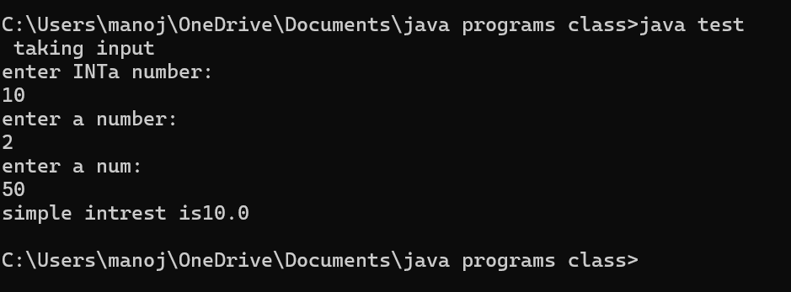

1. **Negative case :**

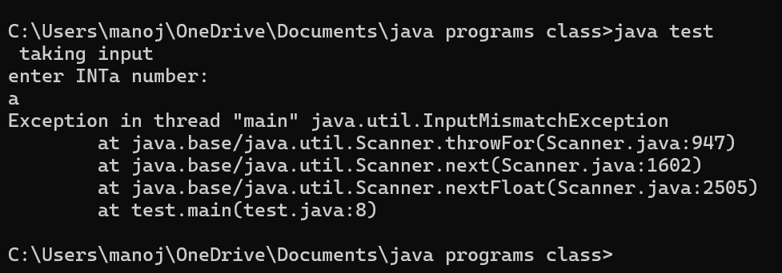

**Error table :**

|  |  |  |  |
| --- | --- | --- | --- |
| **S.No** | **Error type** | **Reason for error** | **rectification** |
| **1** | **Runtime error** | **Incorrect path** | **Copied correct path** |
| **2** | **Syntax error** | **Using incorrect symbols** | **Using correct symbols** |
| **3** | **Logical error** | **Wrong formula** | **Formula rectified** |

1. **Fibonacci sequence to caculate Fibonacci sequence read from user .**

**Important points:**

**Code:**

Import java.util.*;

class zeebra

{

public static void main(String args[])

{

Scanner sc = new Scanner(System.in);

int num;

int f3;

int f1 = 0;

int f2 = 1;

int i = 2;

System.out.print("Enter a number:");

num = sc.nextInt();

System.out.println(f1);

System.out.println(f2);

while(i<num)

{

f3 = f1+f2;

f1 = f2;

f2 = f3;

System.out.println(f3);

i = i+1;

}

}

}

**1.Positive case :**

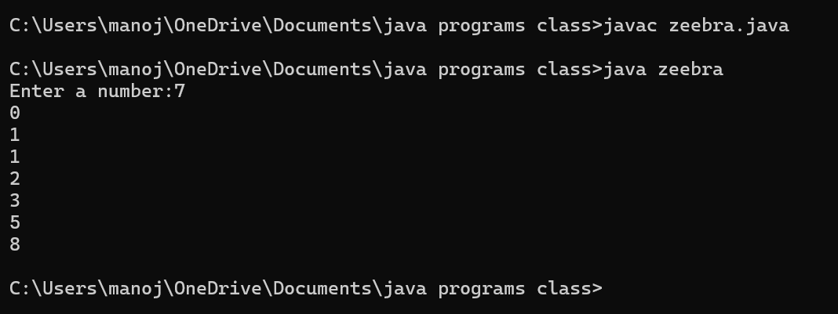

**2.Negative case :**

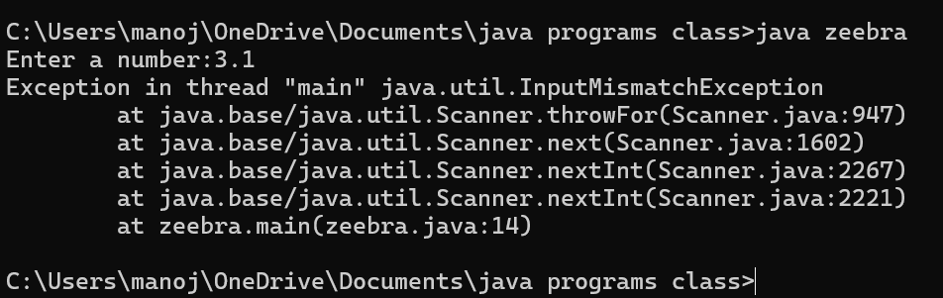

**Error table :**

|  |  |  |  |
| --- | --- | --- | --- |
| **S.No** | **Error type** | **Reason for error** | **Rectification** |
| **1** | **Logical error** | **Incorrect formula** | **Using correct formula** |
| **2** | **Syntax error** | **Incorrect symbols** | **Using correct symbols** |
| **3** | **Runtime error** | **Incorrect path** | **Copied correct path** |

1. **AIM: write a java program to convert temperature from fahrenheat to celcius**

**Code :**

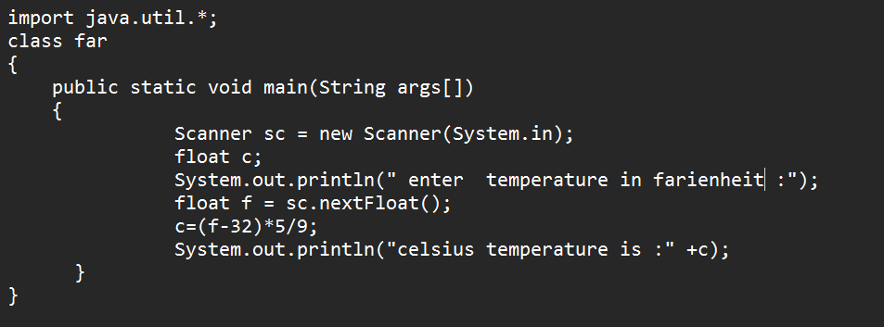

OUTPUT:

1. Positive case :

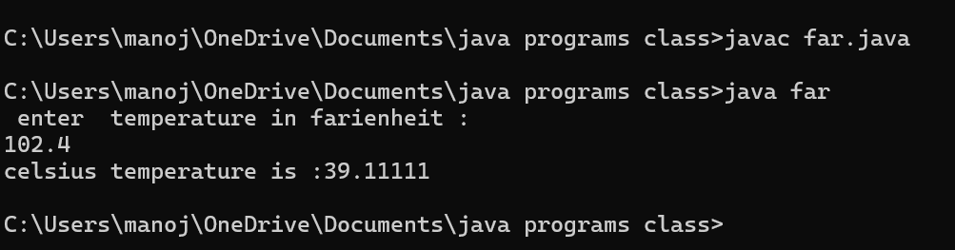

**2.negative case:**

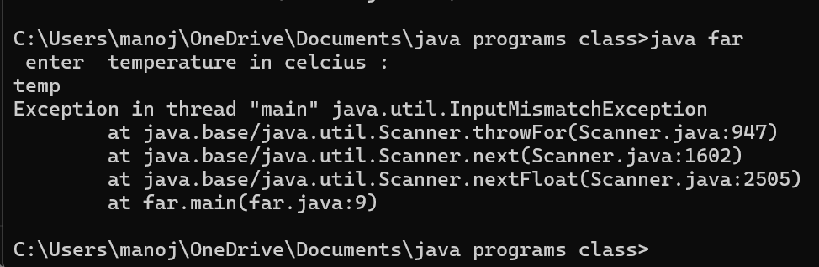

|  |  |  |  |
| --- | --- | --- | --- |
| **S.No** | **Error type** | **Reason for error** | **rectification** |
| **1.** | **Syntax** | **Incorrect symbol** | **Using correct symbols** |
| **2.** | **Logical error** | **Due to incorrect formula** | **Corrected by giving correct formula** |
| **3.** | **Runtime error** | **Incorrect path** | **Using correct path** |

1. **AIM:**

**Write a java program to calculate factorial of a number read from user**

**Code:**

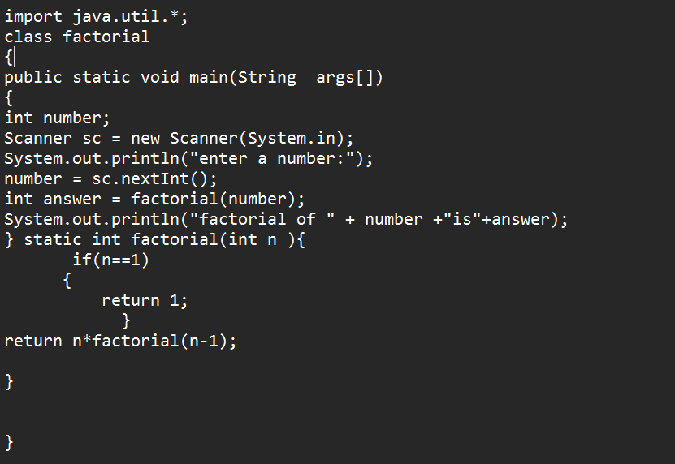

Output:

1.Positive case :

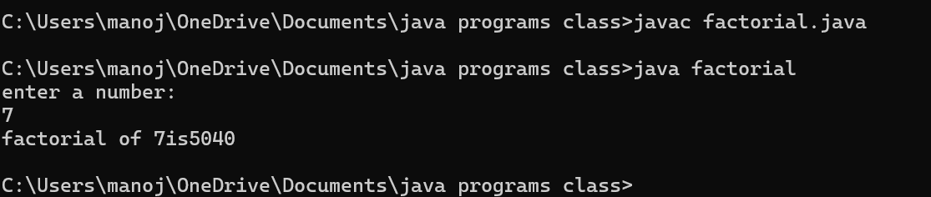

2.Negative case:

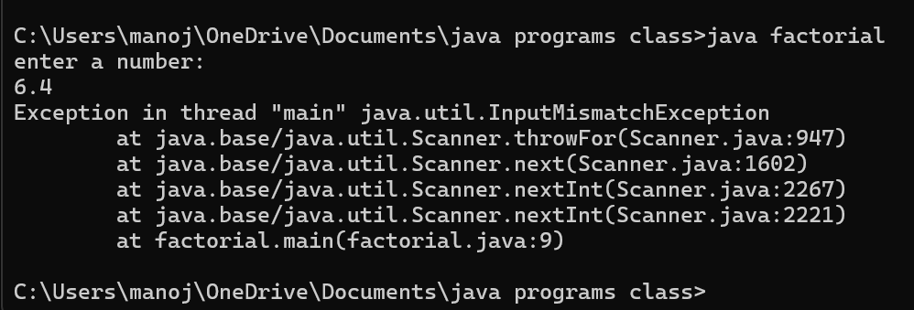

**Error table:**

|  |  |  |  |
| --- | --- | --- | --- |
| **S.No** | **Error type** | **Reason for error** | **rectification** |
|  | **Logical error** | **Incorrect formula** | **Correcting formula** |
|  | **Runtime error** | **Incorrect path** | **Using correct path** |
|  | **syntax** | **Incorrect symbols** | **Using correct symbols** |

**6. AIM:Write a Java program to convert temperature from celcius to farenheit:**

**Code:**

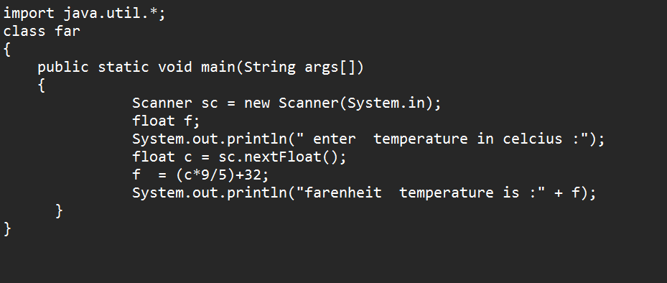

Output:

1. Positive case :

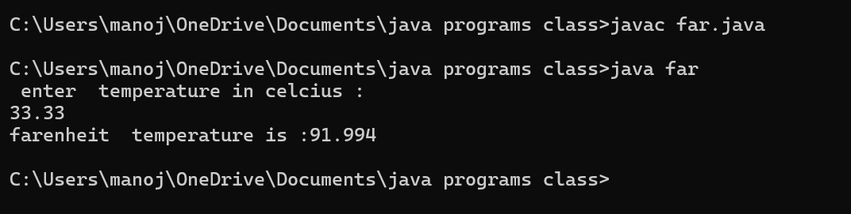

1. Negative case:

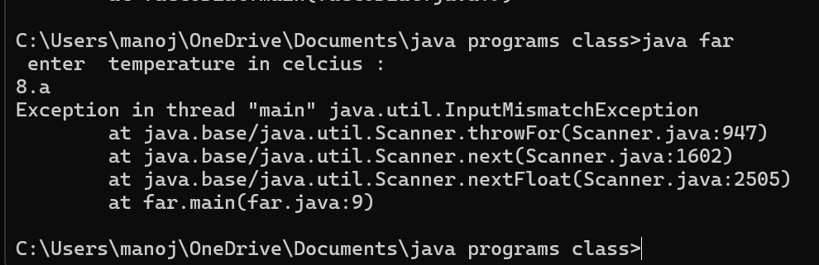

Error table:

|  |  |  |  |
| --- | --- | --- | --- |
| **S.No** | **Error type** | **Reason for error** | **rectification** |
| **1.** | **Logical error** | **Incorrect formula** | **Correcting formula** |
| **2.** | **Runtime errror** | **Incorrect path** | **Using correct path** |
| **3.** | **Syntax error** | **No symbols** | **Using correct symbols** |

1. **AIM:**

**Write a Java program to find area of triangle using herons’s formula :**

**Import points:**

**Code:**

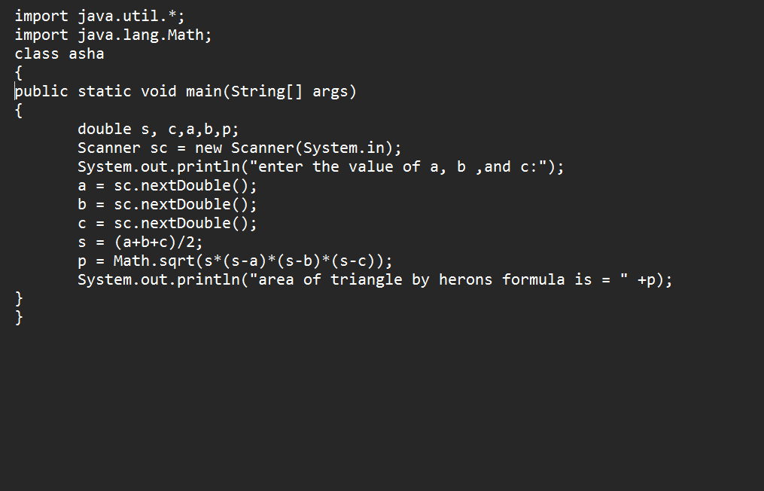Output:

1.Positive case :

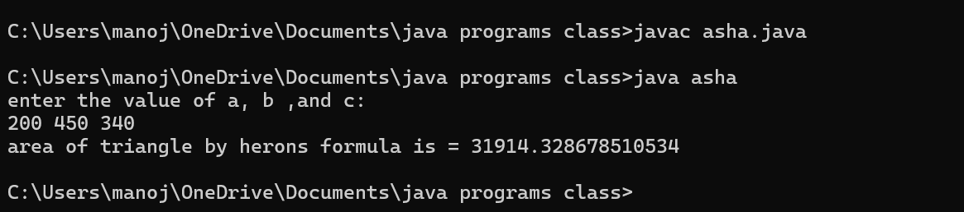

2.Negative case :

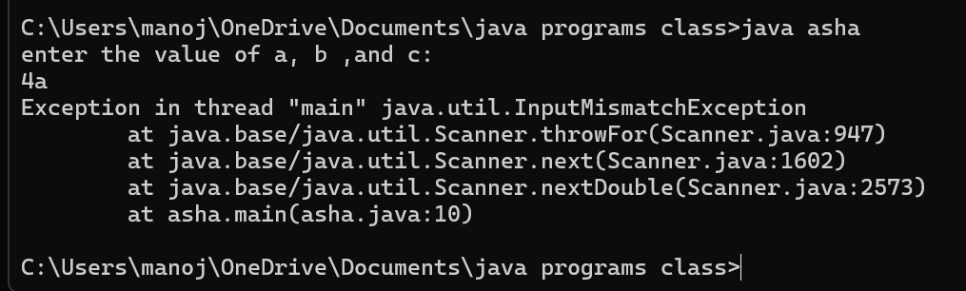

**Error table:**

|  |  |  |  |
| --- | --- | --- | --- |
| **S.No** | **Error type** | **Reason for error** | **rectification** |
| **1.** | **Logical error** | **Incorrect formula** | **Correcting formula** |
| **2.** | **Runtime errror** | **Incorrect path** | **Using correct path** |
| **3.** | **Syntax error** | **Incorrect symbols** | **Using correct symbols** |

**Week -3(lab)**

1. AIM:

To create java program with following instructions :

1. Create a class with name car
2. Create four attributes named car_color ,car_brand,

Fuel_type, milage

1. Create three methods named start(),stop(),service()
2. Create three objects named car1 ,car2 ,car3.

**IMPORTANT POINT:**

1. **CONSTRUCTOR:** A constructor in Java is a special method that is used to initialize objects. It is automatically called when an object of a class is created.

**Key Features of a Constructor:**

1. Same Name as the Class: The constructor name must be the same as the class name.
2. No Return Type: Constructors do not have a return type (not even void).
3. Called Automatically: It runs automatically when an object is created.

**ATTRIBUTES:**

In Java, attributes (also called fields or instance variables) are used to store the state or properties of an object**.**

**METHODS:**

**A method in Java is a block of code that performs a specific task. It is used to increase code reusability, modularity, and maintainability**

**Code :**

**import java.util.*;**

**class car**

**{**

**public String color;**

**public String brand;**

**public String fuel;**

**public int mileage;**

**public void start()**

**{**

**System.out.println("Car Started:");**

**System.out.println("Car color is :"+color);**

**System.out.println("Car Brand is:"+brand);**

**System.out.println("Car fuel type is:"+fuel);**

**System.out.println("Car mileage is:"+mileage);**

**}**

**public void service()**

**{**

**System.out.println("Car Service:");**

**System.out.println("Car color is :"+color);**

**System.out.println("Car Brand is:"+brand);**

**System.out.println("Car fuel type is:"+fuel);**

**System.out.println("Car mileage is:"+mileage);**

**}**

**public void stop()**

**{**

**System.out.println("Car Stop:");**

**System.out.println("Car color is :"+color);**

**System.out.println("Car Brand is:"+brand);**

**System.out.println("Car fuel type is:"+fuel);**

**System.out.println("Car mileage is:"+mileage);**

**}**

**public static void main(String args[])**

**{**

**car car1 = new car();**

**car1.color = "Black";**

**car1.brand = "MARUTHI";**

**car1.fuel = "Deisel";**

**car1.mileage = 80;**

**car1.start();**

**car car2 = new car();**

**car2.color = "BLUE";**

**car2.brand = "hundai";**

**car2.fuel = "petrol";**

**car2.mileage = 120;**

**car2.stop();**

**car car3 = new car();**

**car3.color = "maroon";**

**car3.brand = "shift";**

**car3.fuel = "deisel";**

**car3.mileage = 100;**

**car3.service();**

**}**

**}**

**Output :**

**1.Positive case**

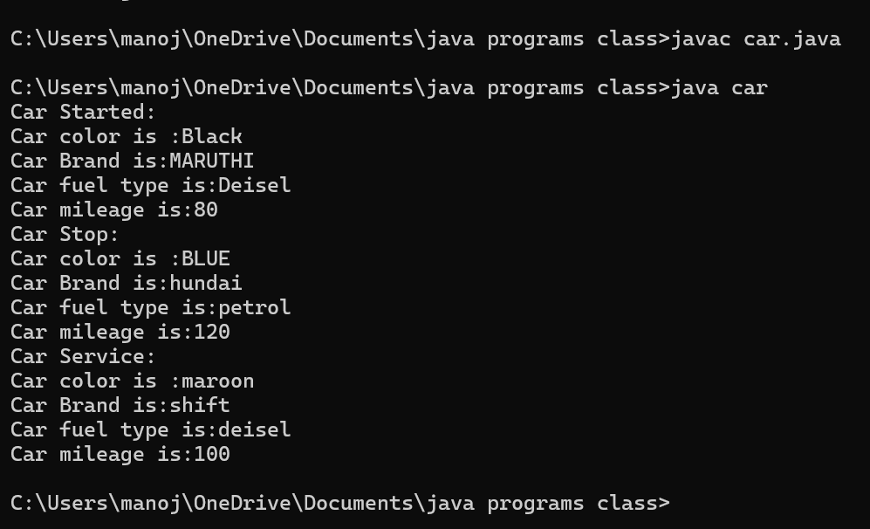

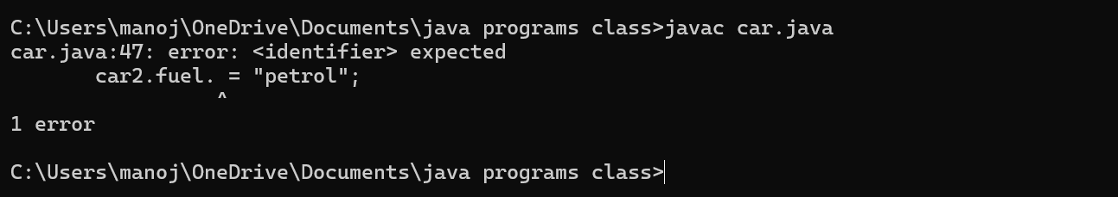**2.Negative case**

**Error table:**

|  |  |  |  |
| --- | --- | --- | --- |
| **S.No** | **Error type** | **Reason for error** | **rectification** |
| **1.** | **Logical error** | **Incorrect formula** | **Correcting formula** |
| **2.** | **Runtime errror** | **Incorrect path** | **Using correct path** |
| **3.** | **Syntax error** | **Incorrect symbols** | **Using correct symbols** |

**CLASS DIAGRAM:**

|  |
| --- |
| **Class Name = Car** |
| **Attributes :**  **-Color= String**  **-Brand = String**  **- Fuel = String**  **-Milage= Int** |
| **Methods**  **+Start():Void**  **+Stop():Void**  **+Service() :Void** |
|  |

1. **AIM:**

**TO CREATE A CLASS BANK ACCOUNT WITH METHODS DEPOSIT() AND WITHDRAWL()**

**CODE:**

class BankAccount {

public String Acchname;

public int Accnumber;

public double curramount;

// Constructor to initialize account details

BankAccount(String Acchname, int Accnumber, double curramount) {

this.Acchname = Acchname;

this.Accnumber = Accnumber;

this.curramount = curramount;

System.out.println("Account Created:");

System.out.println("Account Holder: " + Acchname);

System.out.println("Account Number: " + Accnumber);

System.out.println("Current Balance: $" + curramount);

System.out.println("---------------------------");

}

// Method to withdraw money

public void withdraw(double withdraw) {

if (withdraw > curramount) {

System.out.println("Insufficient Funds!");

} else {

curramount -= withdraw;

System.out.println("Withdrawn: $" + withdraw);

System.out.println("Updated Balance: $" + curramount);

}

System.out.println("---------------------------");

}

// Method to deposit money

public void deposit(double deposit) {

curramount += deposit;

System.out.println("Deposited: $" + deposit);

System.out.println("Updated Balance: $" + curramount);

System.out.println("---------------------------");

}

// Main method

public static void main(String args[]) {

// Creating a bank account object

BankAccount account1 = new BankAccount("krishna manoj", 116117, 100089.0);

// Performing transactions

account1.deposit(500);

account1.withdraw(300);

account1.withdraw(1000500); // Should show "Insufficient Funds"

}

}

**OUTPUT:**

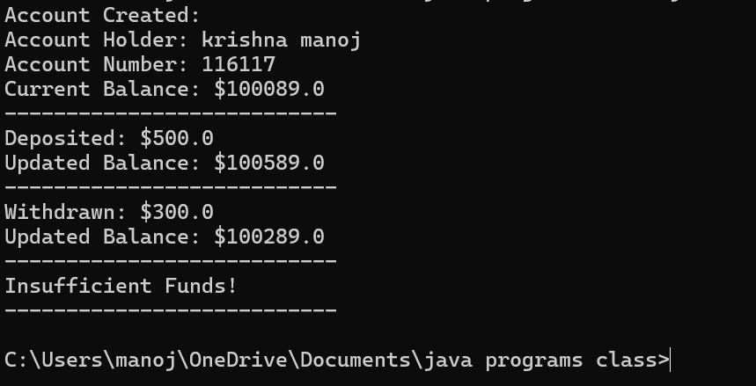**1.POSITIVE CASE:**

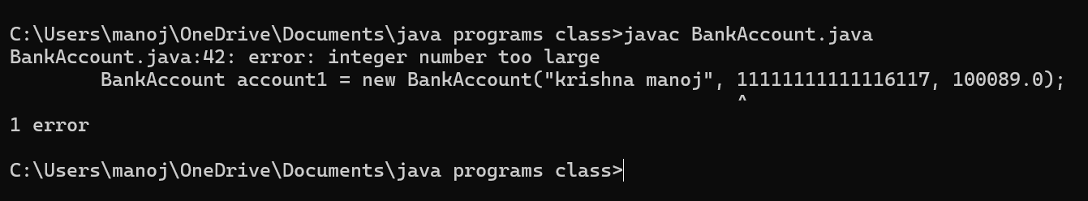**2. NEGATIVE CASE:**

**Error table:**

|  |  |  |  |
| --- | --- | --- | --- |
| **S.No** | **Error type** | **Reason for error** | **rectification** |
| **1.** | **Logical error** | **Incorrect formula** | **Correcting formula** |
| **2.** | **Runtime errror** | **Incorrect path** | **Using correct path** |
| **3.** | **Syntax error** | **Incorrect symbols** | **Using correct symbols** |

**CLASS DIAGRAM:**

|  |
| --- |
| **CLASS = BankAccount** |
| **ATTRIBUTES:**  **- Acchname: String**  **- Accnumber: int**  **- curramount: double** |
| **METHODS:**  **+ BankAccount(Acchname: String, Accnumber: int, curramount: double)**  **+ Withdrawl:Void**  **+Deposit :Void** |
|  |

**WEEK – 4 (LAB)**

1. **AIM:**

**Write a java program with class named book ,the class should contain various attributes such as title , author , year of publication , it should also contain a constructor parameters which initializes title , author , year of publication**

**Create a method which displays details of the book**

**Display details of two books**

**Syntax:**

import java.util.*;

class book

{

public String title;

public String author;

public int year;

public void ashabhosle()

{

System.out.println(" book - ashabhosle:");

System.out.println("the title is :"+title);

System.out.println("THE NAME OF AUTHOR : " +author);

System.out.println("YEAR OF PUBLICATION :"+year);

System.out.println("-------------------------------------------");

}

public void kishorekumar()

{

System.out.println(" book -kishorekumar:");

System.out.println("the title is :"+title);

System.out.println("THE NAME OF AUTHOR : " +author);

System.out.println("YEAR OF PUBLICATION :"+year);

System.out.println("-------------------------------------------");

}

public static void main(String args[])

{

book book1 = new book();

book1.author = " R .K .NARAYAN " ;

book1.title = " MALGUDI DAYS " ;

book1.year = 1953;

book1.ashabhosle() ;

book book2 = new book();

book2.author = " MOHMMAD RAFI ";

book2.title = " VOICE OF INDIA - ASHA BHOSLE" ;

book2.year = 1972;

book2.kishorekumar();

}

}

**Output:**

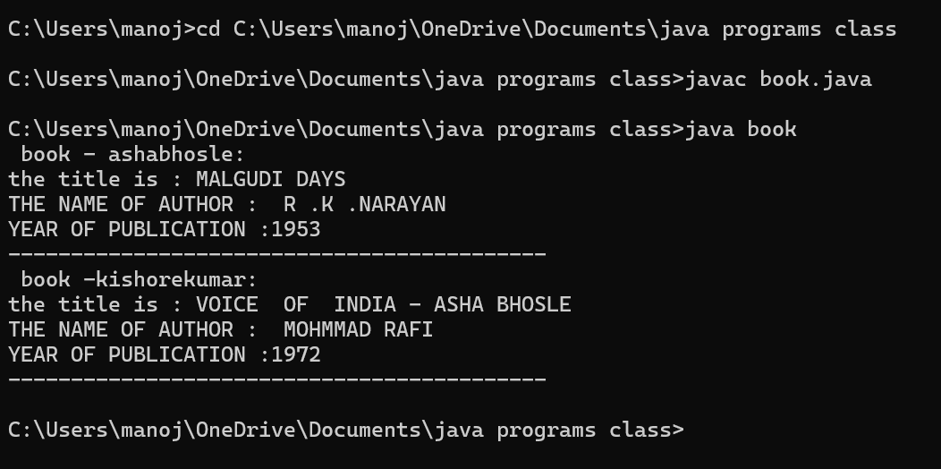**1.Positive cases :**

**2.Negative case :**

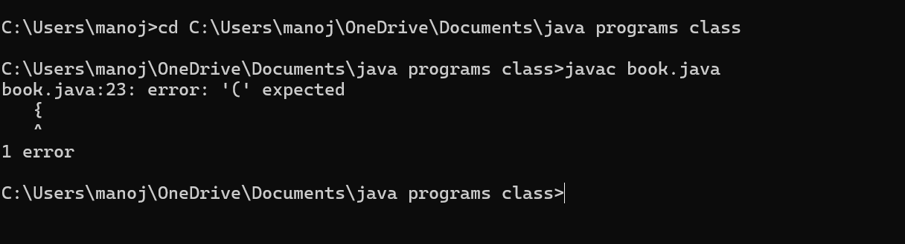

**ERROR TABLE:**

|  |  |  |  |
| --- | --- | --- | --- |
| **S.No** | **Error type** | **Reason for error** | **rectification** |
| **1.** | **Logical error** | **Incorrect formula** | **Correcting formula** |
| **2.** | **Runtime errror** | **Incorrect path** | **Using correct path** |
| **3.** | **Syntax error** | **Incorrect symbols** | **Using correct symbols** |

**Class diagram:**

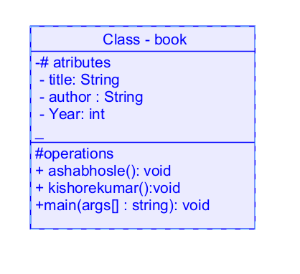

1. **AIM:**

**Create a java program with class name myclass with static variable count of int type ; initialized to zero and a constant variable “pi’**

**Of type double initialized to 3.14 as attribute of that class , now define a constructor for “ my class “ that increment the count variable each time an object of my class is created count = 0 ,finally print the final values of “count” ans pi variable ,create 3 objects**

**Code:**

class myclass

{

static int count=0;

final double pi=3.14;

myclass()

{

count = count+1;

}

public void set()

{

System.out.println("Count is:"+count);

System.out.println("Pi value is:"+pi);

}

public static void main(String args[])

{

myclass m = new myclass();

System.out.println(count);

m.set();

myclass n = new myclass();

System.out.println(count);

n.set();

myclass l = new myclass();

System.out.println(count);

l.set();

System.out.println("Final count is:"+count);

System.out.println(m.pi);

}

}

Output:

1.positive case:

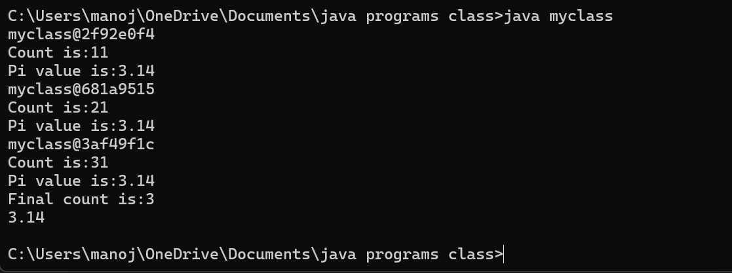

2.negative case:

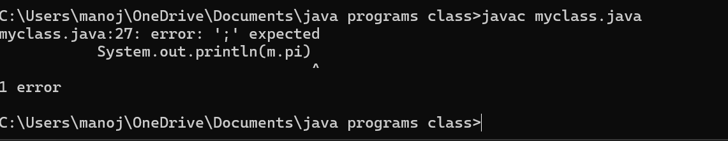

Error table:

|  |  |  |  |
| --- | --- | --- | --- |
| **S.No** | **Error type** | **Reason for error** | **rectification** |
| **1.** | **Logical error** | **Incorrect formula** | **Correcting formula** |
| **2.** | **Runtime errror** | **Incorrect path** | **Using correct path** |
| **3.** | **Syntax error** | **Incorrect symbols** | **Using correct symbols** |

Class diagram :